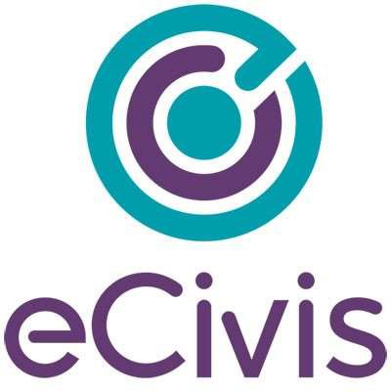

Rhode Island Grantor Acceptance Feedback Form

Contents
Overview 2
Steps to Access Your Application for Review 2
Reviewing your Application for Acceptance 5
Program Name 5
Required Fields 5
Help Text 5
# Of Uploads per Application 5
Providing Feedback and/or Acceptance 5
Email Support 5
Acceptance 6
Publishing Solicitation 6

Overview
This user guide outlines the steps a Rhode Island agency user needs to complete to review their configured application and report feedback to eCivis Support. This user guide will walk through how to sign in and review your configured application compared to what you submitted in your Intake Form.

Steps to Access Your Application for Review
- Click on the URL provided by email to the Primary Workspace user entered in the Submission tab of the solicitation. This URL will come from an eCivis staff member at support@ecivis.com. The URL you are visiting is the end result of your configured application. This is a very similar view to what your application will look like to your applicants.

- Click the blue “log in” button:
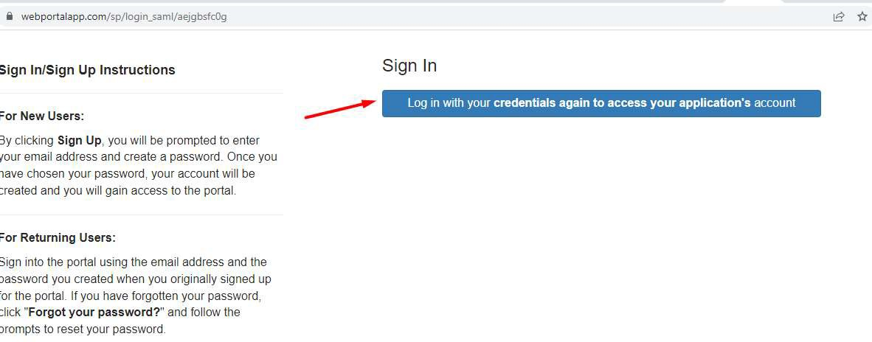

- Click the blue eCivis Login button:

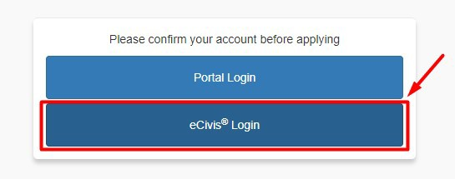

- Enter your eCivis log in information and click log in:
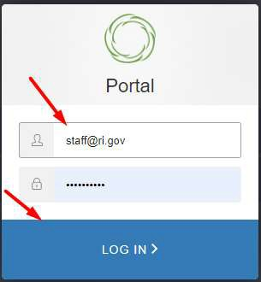

- 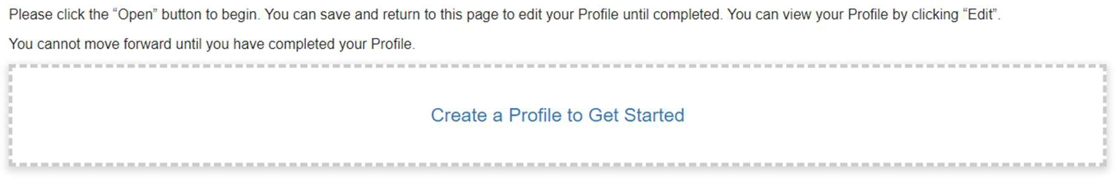Once logged in, complete the Profile. This is the first section that is configurable per the Intake Form. You can enter dummy data to get through this stage. To begin, click on “Create a Profile to Get Started”

- Review the Profile Form to ensure it matches what you have inputed in your Intake Form. Once all fields with a red asterisk have been completed, select “Create Profile”
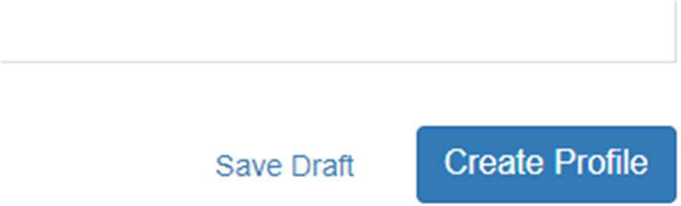

- Once you complete your profile, you can select the plus button tile that says “Get Started.”
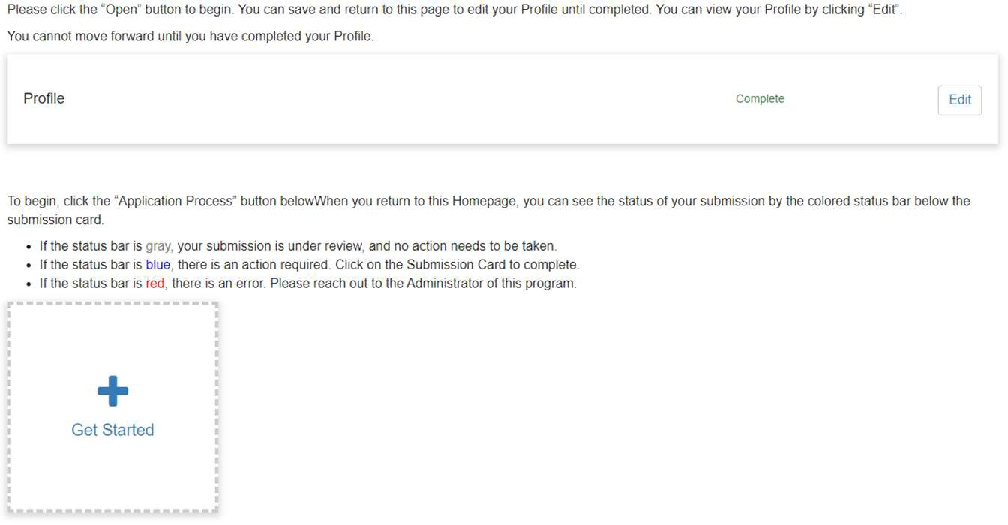
- Next to Applications, click Open
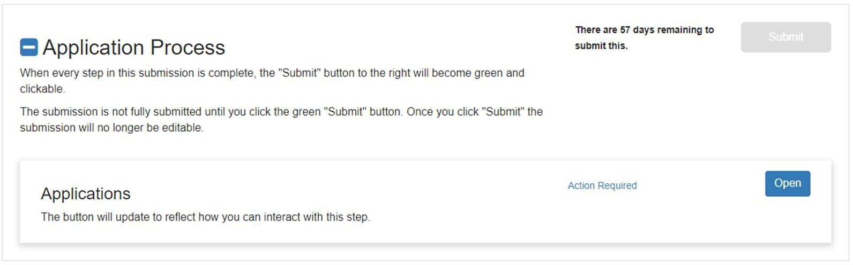
- Review the Application form to ensure it matches what you have entered in your Intake Form. You are checking for:
  - Fields to be marked required with a red asterisk
  - Specific help text
  - File Uploads named as indicated and marked required

- If there are any edits needed, use the below section to send feedback to the eCivis Support Team.

Reviewing your Application for Acceptance

Program Name
Please identify the name of the Program Application you are reviewing. This should match the Grant Program Name you entered in your Solicitation and Intake Form.

Required Fields
Please verify that the all required fields are correctly identified. If fields are incorrectly identified as required/not- required, please provide your feedback below (screenshots, if possible).
Issue #1:
Issue #2:
Issue #3:

Help Text
Please verify that the help text is correct. If the help text is incorrect, please provide your feedback below (screenshots, if possible).
Issue #1:
Issue #2:
Issue #3:

# Of Uploads per Application
Please verify that the number of uploads per application is correct. If it is not, please list the issues you find below. Issue #1:
Issue #2:
Issue #3:

Providing Feedback and/or Acceptance

Email Support
Please send this document to support@ecivis.com. Your changes/corrections will be made, and you will receive notification to review the application again. Changes made by eCivis can be reviewed using the same URL originally sent (step 1).

Acceptance
If you accept the application, email your approval to support@ecivis.com, and no further action is required. If we do not receive feedback, eCivis will assume acceptance.

Publishing Solicitation
Once the application has been accepted, your Solicitation/grant program will sit dormant in eCivis in the “Under Review” stage. When you are ready to publish your solicitation/grant program, email support@ecivis.com that you are ready to publish. Include the name of the solicitation in that email and CC doa.grants@doa.ri.gov on the email.

