Designated Grant Application User Guide – For Applicants
- Navigate to the Designated Grant solicitation Webpage eCivis - Grants Network
- There are 5 tabs to help describe the solicitation, please read through these items to learn more about designated grants and who to contact for user support.
- Next, click on the ‘Files’ tab, and download both the Budget Summary & Budget Detail Forms if you do not have them already. You will need to complete and upload these files as part of your application.

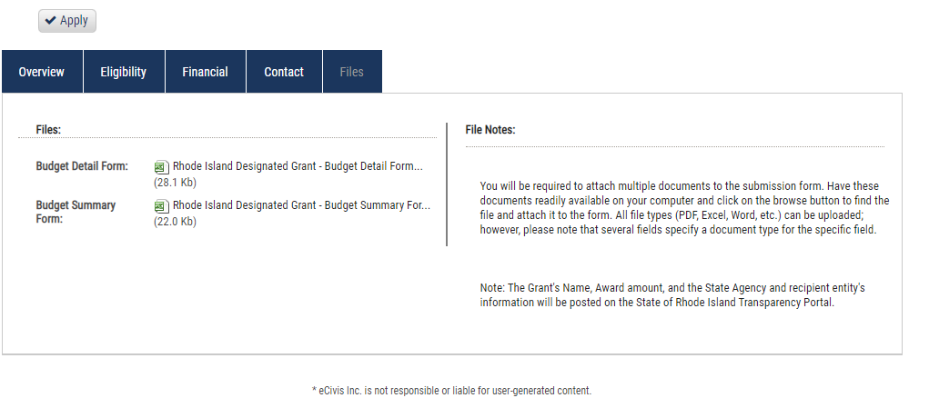
- Once you have downloaded the Budget Summary and Budget Detail Form – Click the “Apply” button above the solicitation

- You will now be prompted to log in. If this is your first time logging into the eCivis Portal, you will need to click on the green Create an Account button and enter your first name, last name, email address, and create a password. If you have already have an account, enter your username and password and click Portal Login.

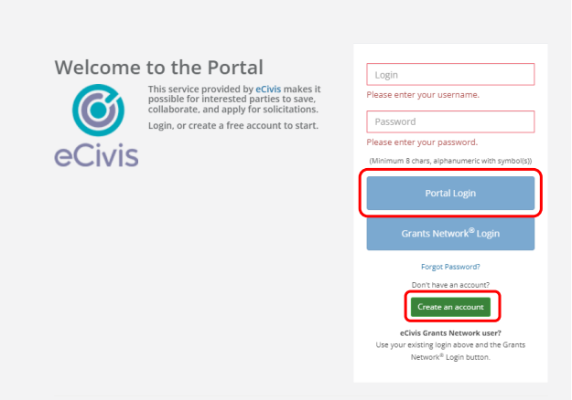

- Once you have created your account and logged in, click on the My Profile option in the top left corner of your screen.
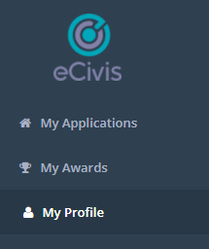
- You will now be on the Profile Page. Every user in the Grants Management System (GMS) must have a profile attached to their account. Please fill out the information on this form and hit Mark Complete when you are finished.

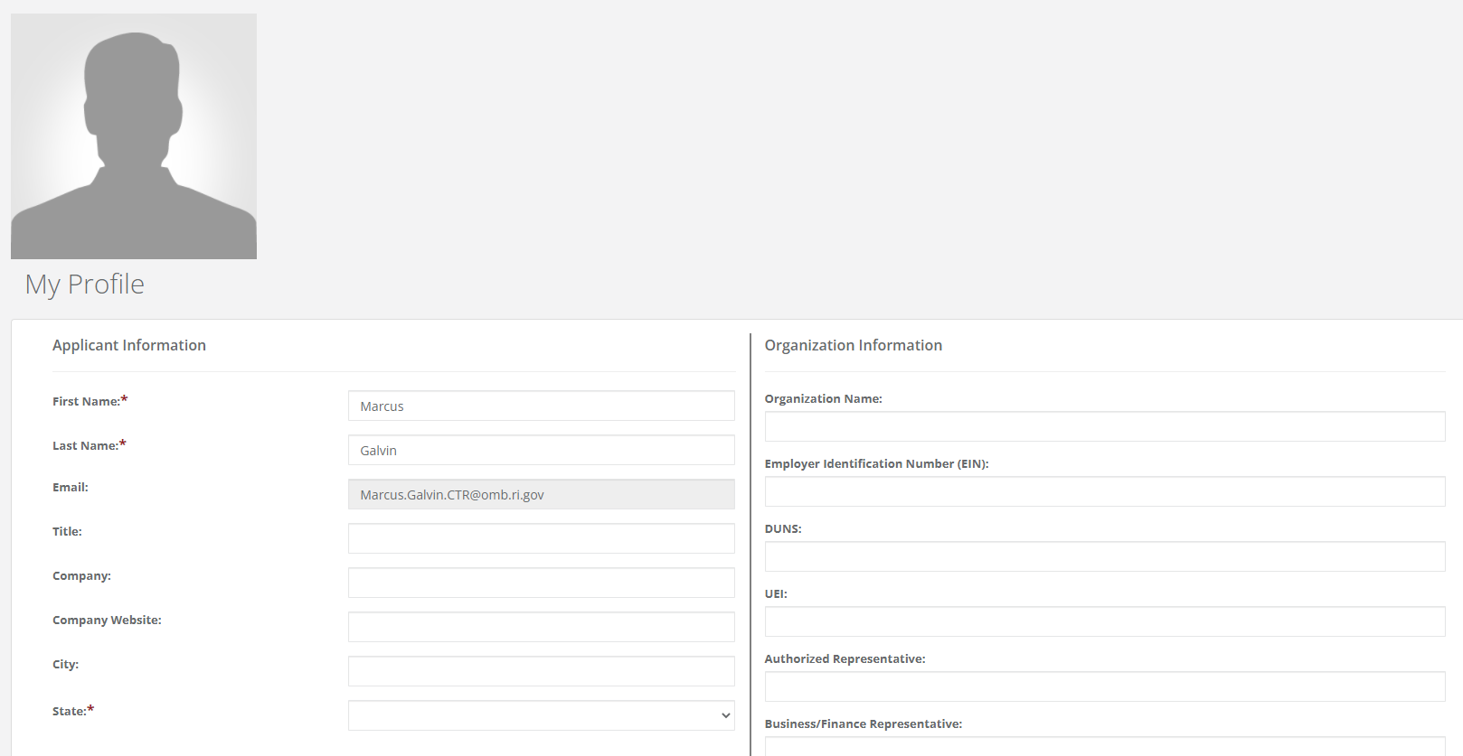
- Once the Profile is filled out, navigate back to the home page to start filling out your Designated Grant Application: Navigate to and click on Create New Application
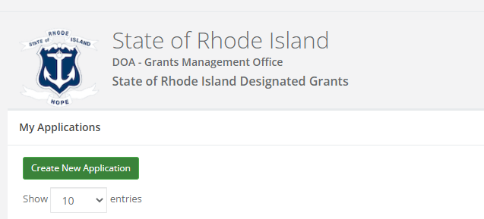

- On the next screen you will begin filling out the application. The first part of the application is called the ‘Profile’. Here you will insert general information about your entity. Navigate to the Profile section on the webpage and click Open in the Profile Box. Afterwards, complete the Profile Section by filling out all the required fields.
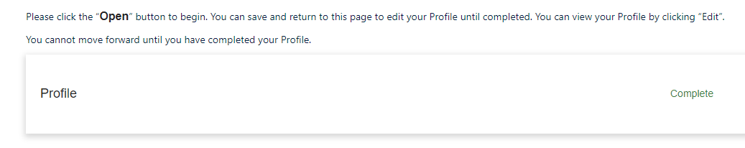
Once you have completed all mandatory fields, you can scroll down and select Mark Complete. If needed, you can always hit Save Draft and your work will be saved and you can come back and finish it at a later time.

- Once you have saved your Profile form, it is now time to fill out the Designated Grant Information of the application & upload the forms. Underneath the Profile section, select the Get Started tile.
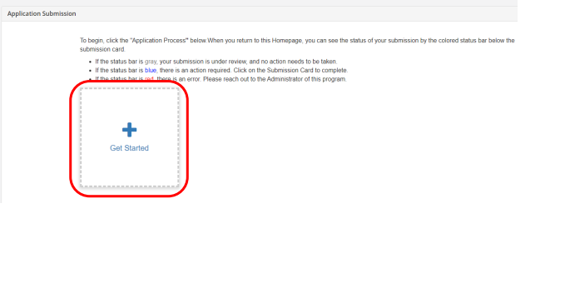
- Next, click the Open Button, to open up the application

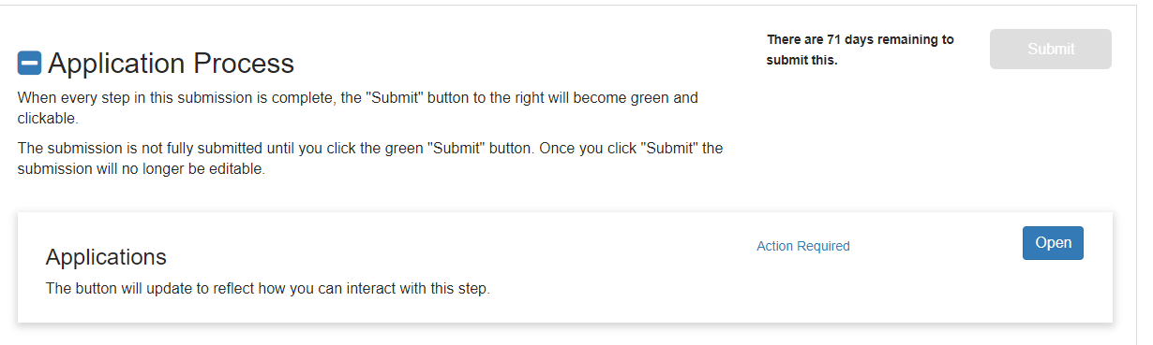
- Follow the Application form, completing all the required fields and uploading the required documents and supplemental forms. When you are finished, click on the Mark Complete button at the end of the application form. You can also save your work as a draft, and return to it at a later time.
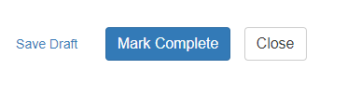
You application will save & you will be directed to a new screen, shown below. If you are ready to submit your application to be reviewed by your State Agency, Click on the Green Submit Option

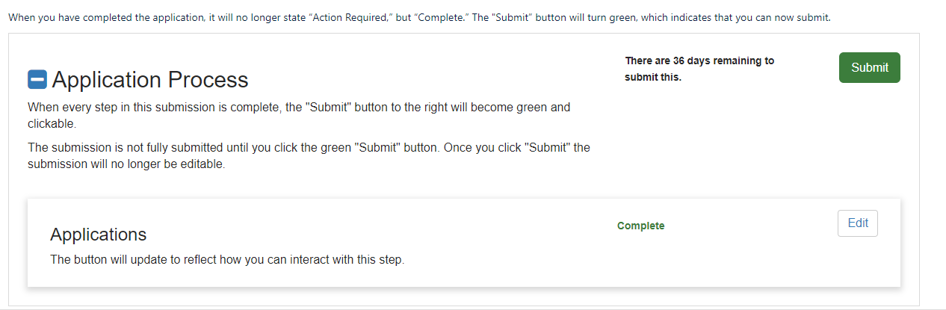

- Congratulations, you have submitted your Designated Grant Application!
- Please await an email from the State Agency who issued this award to your entity. They will either ask you to make necessary revisions to your application, or if The Agency is in full agreement with your submitted application – you will receive a Grant Agreement Document to sign from said State Agency.

