Designated Grant User Guide – For Agency Reviewers
- When a recipient entity uploads a new Designated Grant application, you (The Agency Reviewer) will receive an email with a URL Link to access the application to review.
- You can also always access the review portal and view your reviews with this link: https://webportalapp.com/portal/applications_34f1

- Once logged in, you will see a list displaying the Designated Grant Applications assigned to you for review.

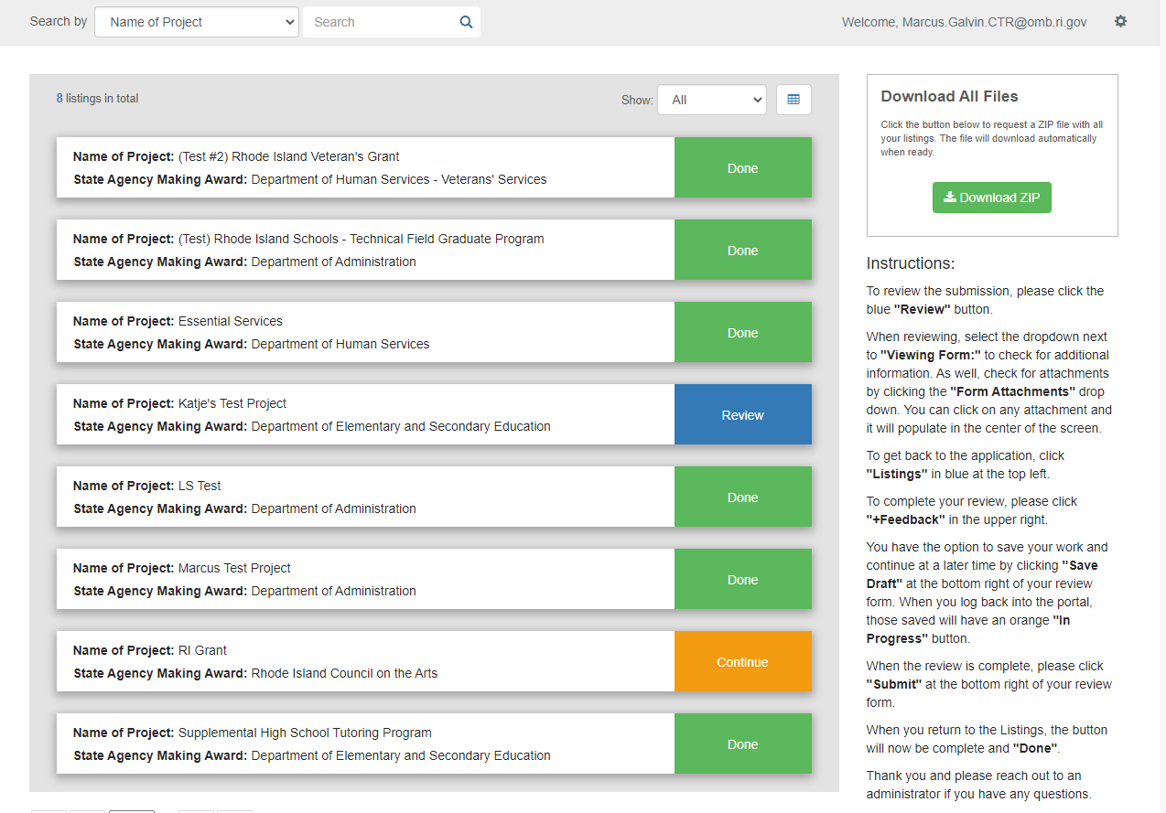

- The Status of the review is displayed to the right of each application.
  - If a review has not been started yet, it will display as a blue box, called Review
  - Once your review has been completed, the box will change to green, and display as Done
  - If you choose to save a review as a draft, the box will be orange, and display as Continue

- To begin reviewing an application, click on the blue Review button, next to the application you want to review.

- On this next screen, please note that there are two sections of the application that must be reviewed by the Agency (Profile and Application). To navigate between these two sections, use the arrows just above the application. The two sections are:

  - The Profile Section
  - The Designated Application Information Section

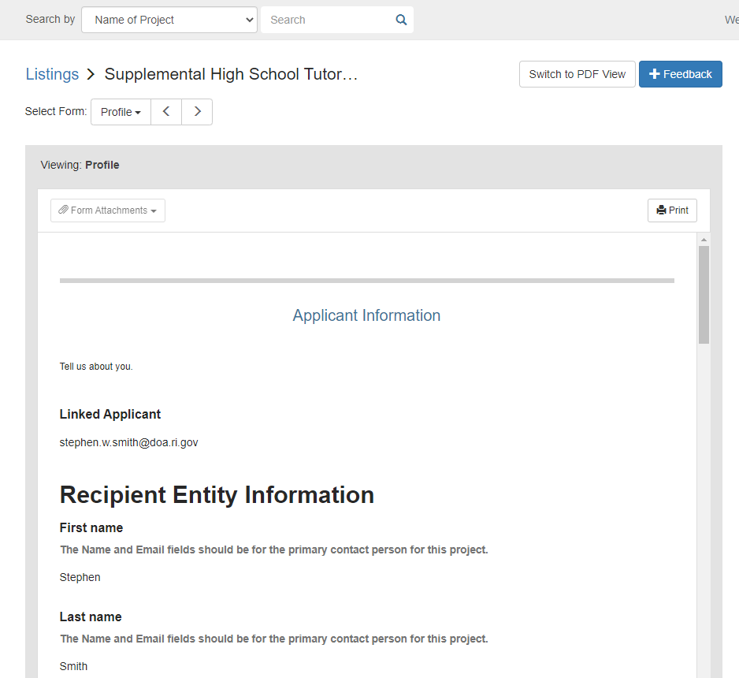

- Next, click on the blue Feedback button which is located to the top-right of the application.

- The Feedback button will display review questions on the right hand side of the application. Mark each question with a response as you review the application.
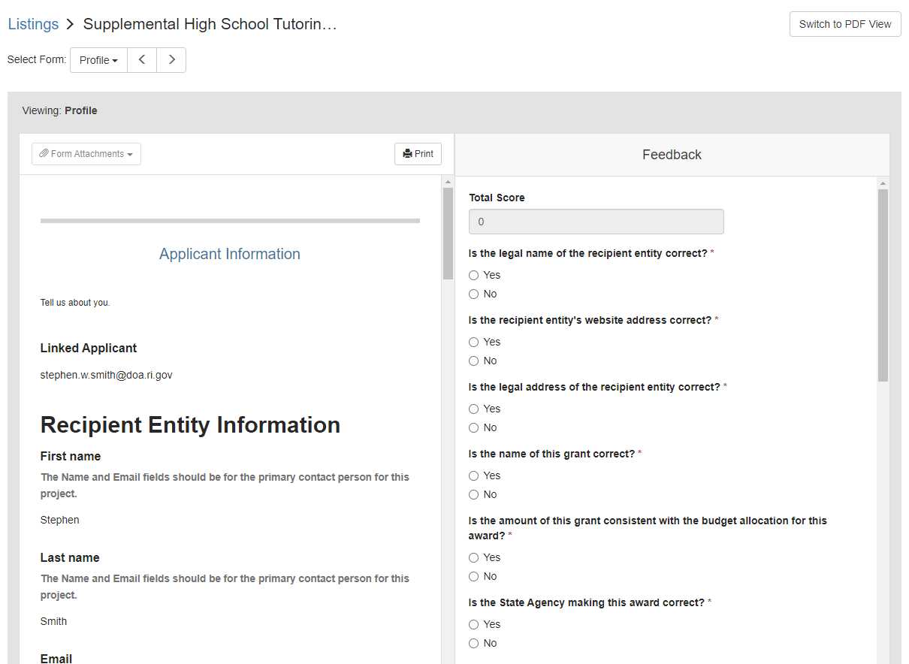

- To view the attachments uploaded by the recipient, go to the application page & click on ‘Form Attachments’ just above the application
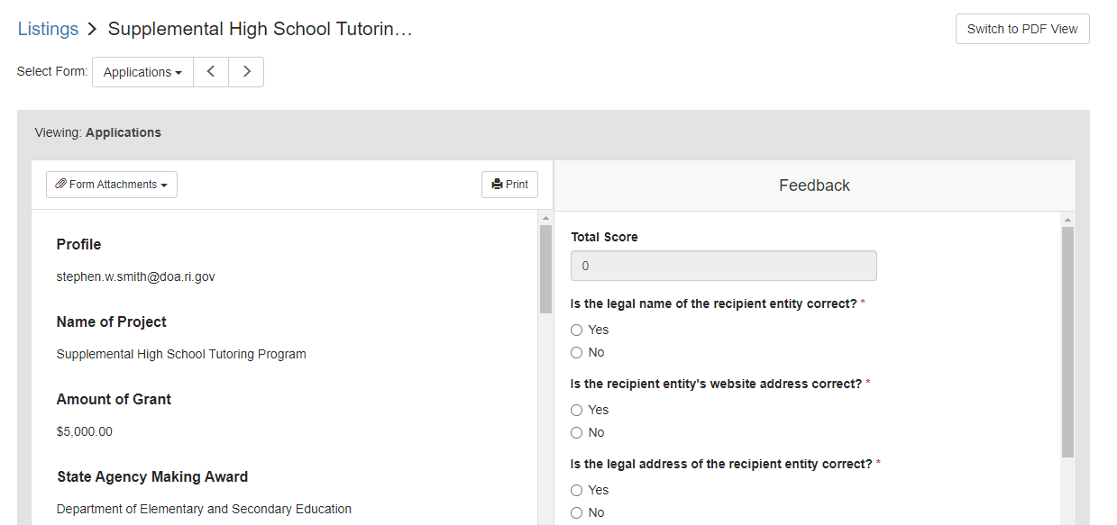

- This will display a drop-down containing all of the supplemental attachments that the recipient attached to this application. You can click on each attachment to open it. You also have the option to download each file individually on this screen.
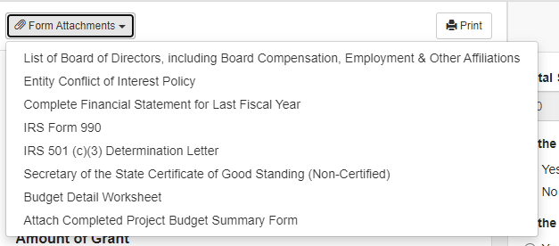

- Traverse the review form, filling out the answers to all the questions while reviewing the recipients Designated Grant Application. When you are finished & believe that the application is completed, click Submit. If you are do not agree with what has been uploaded or if the application is incomplete, save the review as a Draft, and refer to Step 14.
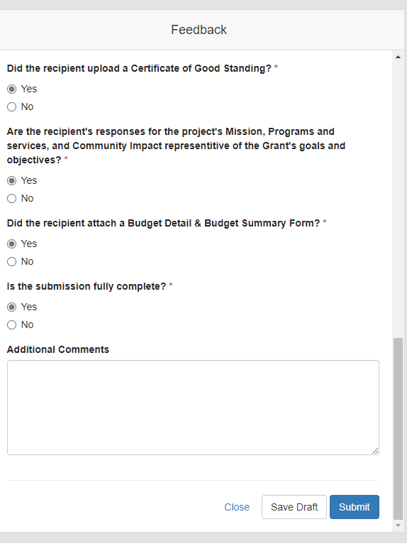

- Once the application has been submitted, it will display as green and Done back on the Home Page.

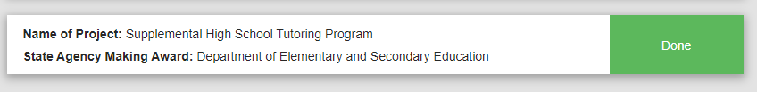

- If during your review, you find the application needs to be revised & save it as a draft, it will display an orange box saying Continue. Once your recipient uploads a revised application, you will return to this draft as you review the revised application.

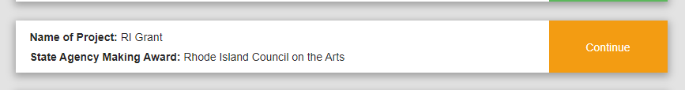

- Congratulations, your recipient’s Designated Grant Application has been Successfully Reviewed!

What if the Recipient Entity’s Applications is incomplete or needs a revision?
- If you need your recipient to make changes to the submitted application after you have reviewed it, you must reach out via email to marcus.galvin.ctr@omb.ri.gov .
- In this email, please list the name of the grant and the individuals name whom uploaded the application. The Grant Management Office, will then move your recipient’s application back into Draft Status.
- The recipient will then receive an email notifying them that their application needs to be revised and a link to go back in the portal and make the appropriate changes.
- After sending the request to marcus.galvin.ctr@omb.ri.gov to re-open the application, you must also send an email to your recipient, notifying them of the changes you wish them to make to their application.
- Once the recipient re-uploads their application with the revised content, you will receive another email notifying you, the Agency, that the application is ready to be reviewed once more.

Addiotnal Information & Guidance for Agency Reviewers

- If needed, a reviewer can export all of their reviews to a zip folder of PDFs. Each application will generate 1 PDF. In the 1 PDF file it will include the following: Profile, Application, all files that were uploaded as attachments with their application.
