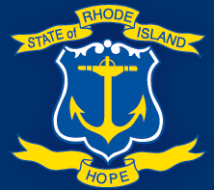
Let’s Be Honest. How are We Doing?

We’re the Retirement Office of the Employees’ Retirement System of Rhode Island (ERSRI), and we’re serious about improving member service!
We’d like you to tell us how we can...
- help you be better prepared for a more financially secure retirement
- provide improved communication to you about your retirement benefits
- better answer your questions about your retirement benefits and how your plan works.
Please visit bit.ly/ERSRIsurvey and complete an anonymous and confidential survey by August 16
Less than 15 minutes is all it’ll take! Visit bit.ly/ERSRIsurvey today!
Questions? Call the ERSRI’s Retirement Office at (401) 462-7600, Monday – Friday,
8:30 a.m. – 4:00 p.m.

